**Homework 2**

**CSE 402: Biometrics and Pattern Recognition**

**Instructor: Dr. Arun Ross**

**Due Date: October 17, 2022 (11:00 pm)**

**Total Points: 60**

**Note:**

**You are permitted to discuss the following questions with others in the class.**

**However, you *must* write up your *own* answers to these questions. Any indication to the contrary will be considered an act of academic dishonesty.**

**A neatly typed report with detailed answers is expected. The report must be uploaded in D2L in PDF format.**  **All outputs, such as graphs and images, must be included in the report.**

**Any code developed as part of the assignment must be (a) included as an appendix in the report, as well as (b) archived in a single zip file and uploaded in D2L.**

**Include a bibliography at the end of the report indicating the resources that you used (e.g., URL, scientific articles, books, etc.) to complete this homework.**

**Please submit the report (PDF) and the code (Zip file) as two separate files in D2L.**

1. [10 points] Consider a scenario wherein a fingerprint-based biometric system is installed in a grocery store in East Lansing. Assume that shoppers have the option of enrolling into the system. This would allow them to render payment at the checkout register by merely placing their index finger on a fingerprint sensor and typing in a 4-digit PIN. After successfully verifying the shopper’s identity, the system would then connect to their bank account and debit the amount of the purchase. Based on the terminology developed in class, explain how you would characterize this biometric system (see Section 1.5.1 in the text book). You must justify your answer with a **detailed** explanation.

**Cooperative** - The goal of the user is to be positively identified by the system in order for their groceries to be properly billed to their accounts. A user who wanted to have an expeditious and smooth checkout experience would follow any direction to be identified.

**Overt** - The grocery store would let the user know about the fingerprint scanning to opt into the program. The user also has to willfully give their fingerprint in order to be identified.

**Habituated Users** - The average person visits a grocery store at least once per week. They would quickly become accustomed to fingerprint checkouts. It would even be safe to say that they would welcome it after some time. Especially when they realize they could provide a fingerprint while waiting for their items to be scanned by a cashier and walk away with their bags as soon as the last item is dropped in.

**Unattended** - It would not be the cashier’s responsibility to guide the shopper’s finger. Instead the user would be on their own to apply the correct pressure and posture to be positively identified. However, a system could be implemented with a senior manager who is instructed in methods to guide a user’s finger in the event of a problematic checkout.

**Controlled** - The fingerprint scanner at a checkout would be located within the store at the checkout station. In the store there is climate control and protection from external elements. Each scanner could also be wiped clean after each use to prevent dirt and oil buildup.

**Closed** - The checkout kiosk’s only duty is to perform a banking confirmation. The templates would only need to be stored electronically by the store. When the store has made a positive identification of the user it could charge the appropriate user’s bank account. The checkout kiosk would not give the user other options to view their bank account.

2. [10 points] (a) What is the main difference between closed-set identification and open-set identification? (b) Consider a watch-list application in an airport where a passenger’s biometric data is used to determine if they are present in a watch-list or not. Is this an example of open-set or closed-set identification? Justify your answer.

1. A closed-set identification will contain a correct identity of the probe. An open-set identification is not guaranteed to contain a correct identity of the probe.
2. Open-Set Identification. The watch-list would only contain people that are on the watch-list itself. All other people would return as not in the database. Since every person visiting the airport is not recorded in the watch-list as “flagged” or “unflagged” it would be open-set.

3. [10 points] A set of 10 fingerprint images may be accessed here. Based on visual examination, determine the class of each of the 10 fingerprints. **Justify your answer.** (For each fingerprint, include the image along with a clear annotation explaining how the class was determined.)

Steps taken to determine image.

1. Increase brightness to remove background distortion.
2. Alter exposure to clarify imagery.
3. Maximize the contrast to embolden lines.
4. Reduce highlights to embolden lines.
5. Minimize shadows reveal smaller details within the fingerprint lines.
6. Highlight or circle significant features.

User001 - right loop

User002 - left loop  
User003 - whorl

User004 - right loop

User005 - whorl

User006 - tented arch

User007 - whorl

User008 - plain arch

User009 - tented arch

User010 - left loop

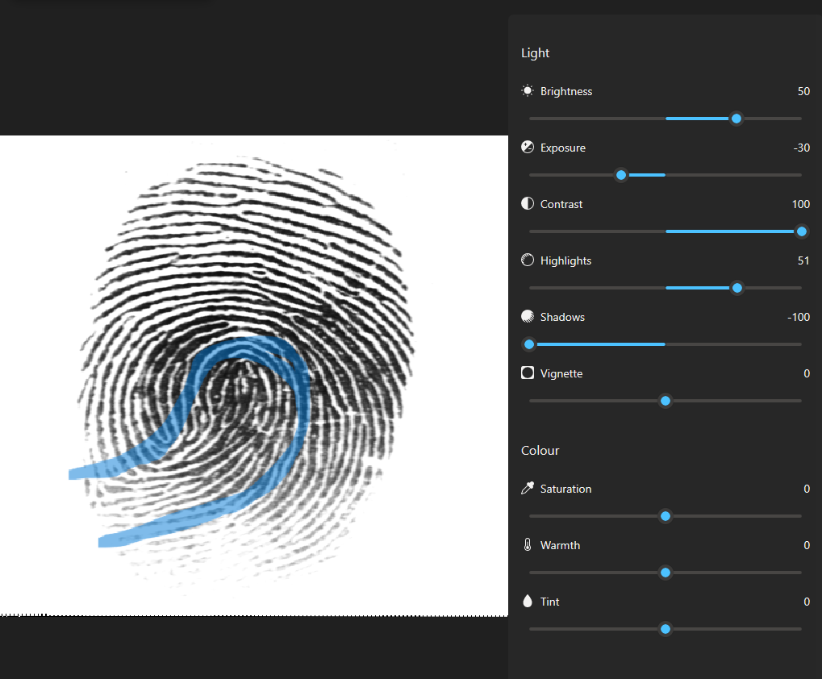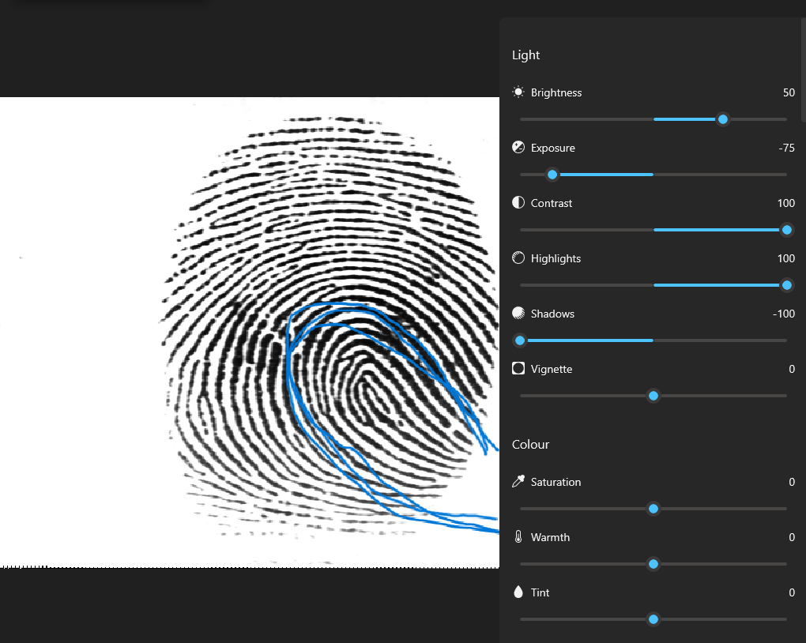

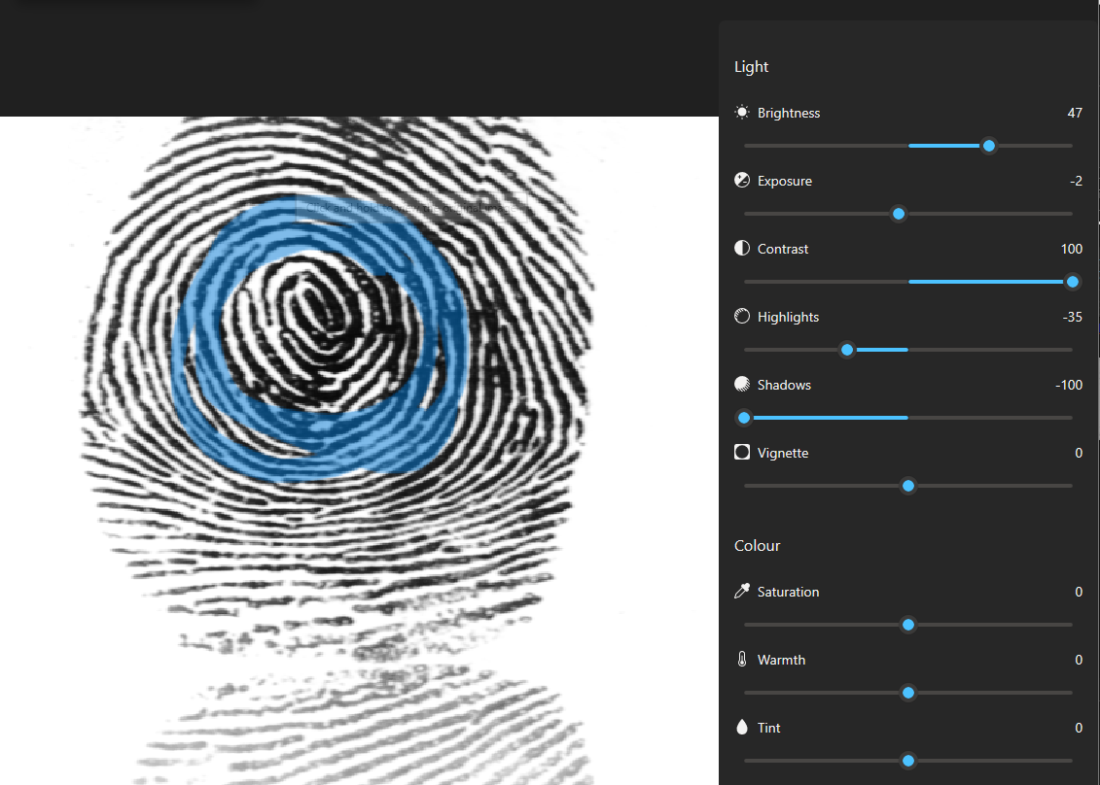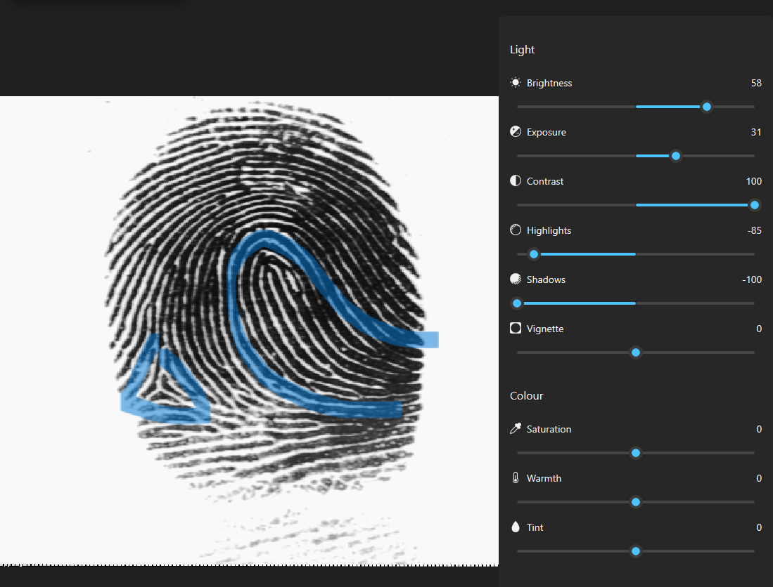

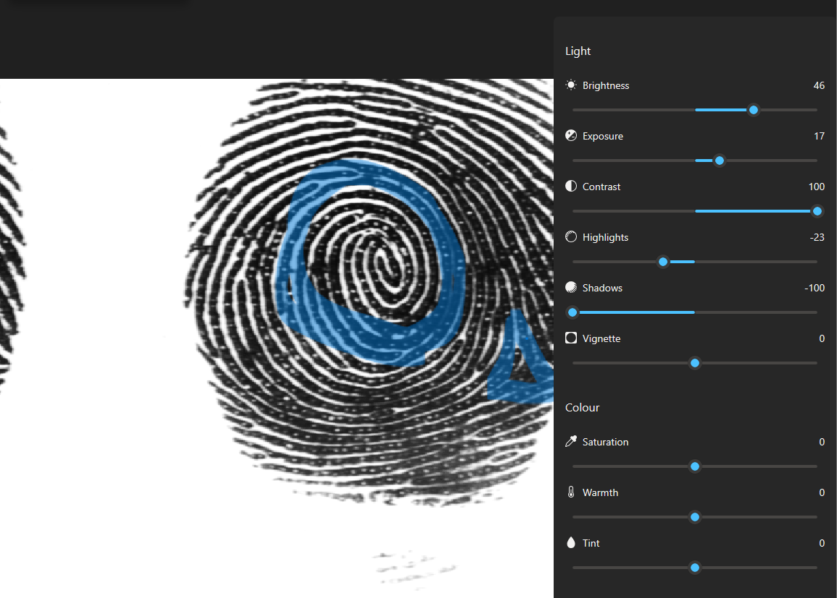

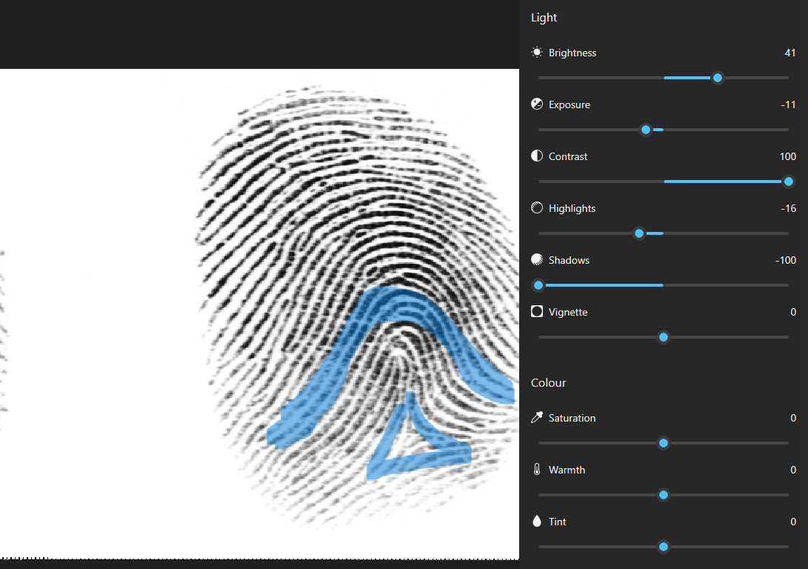

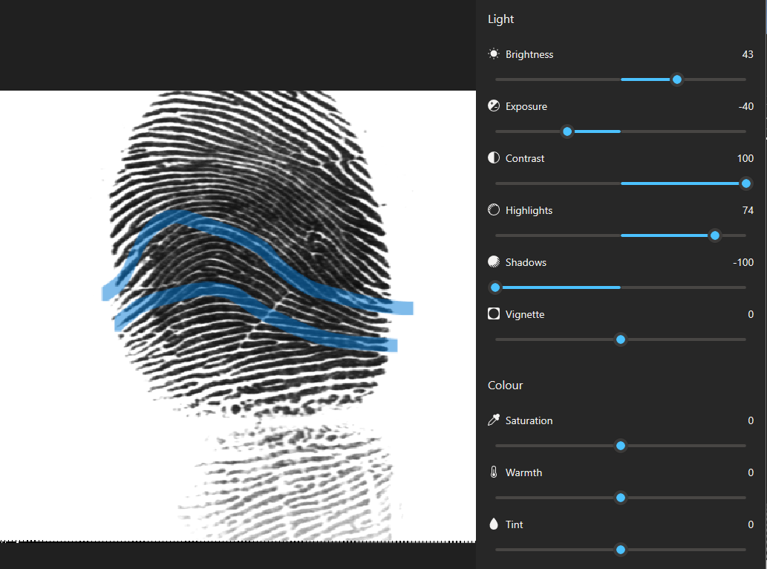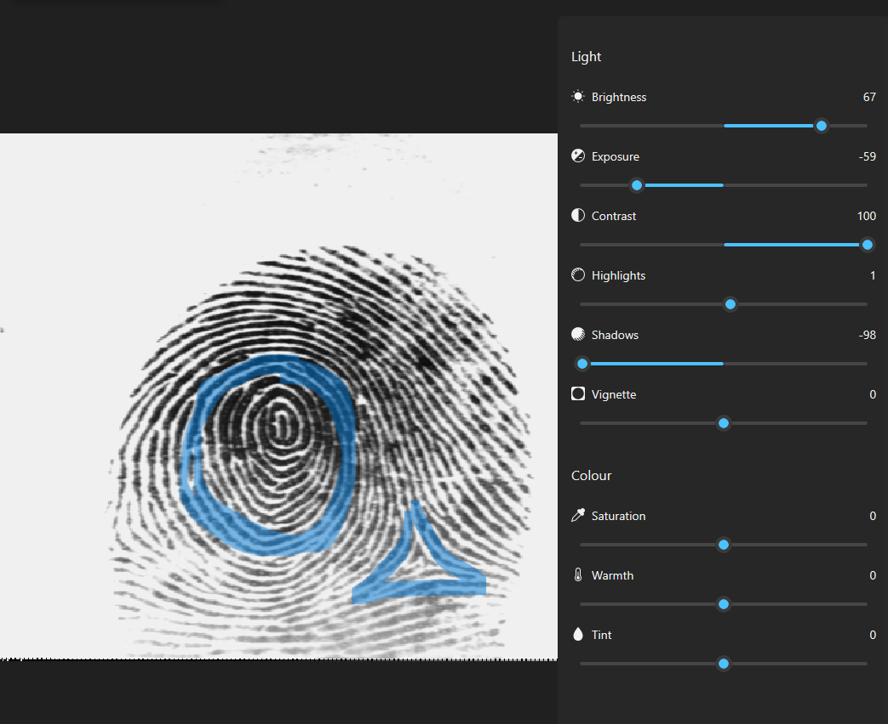

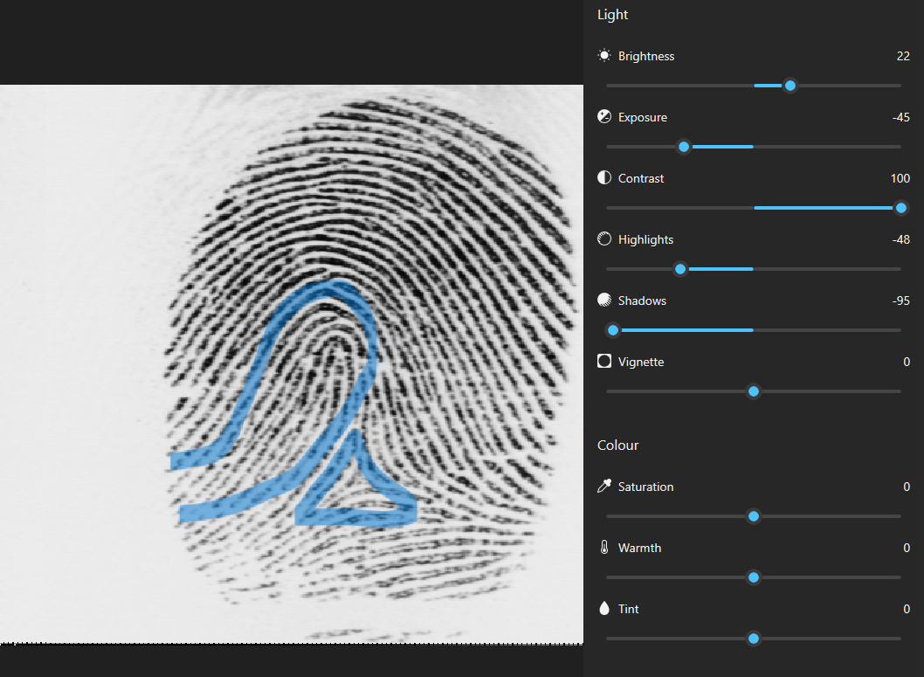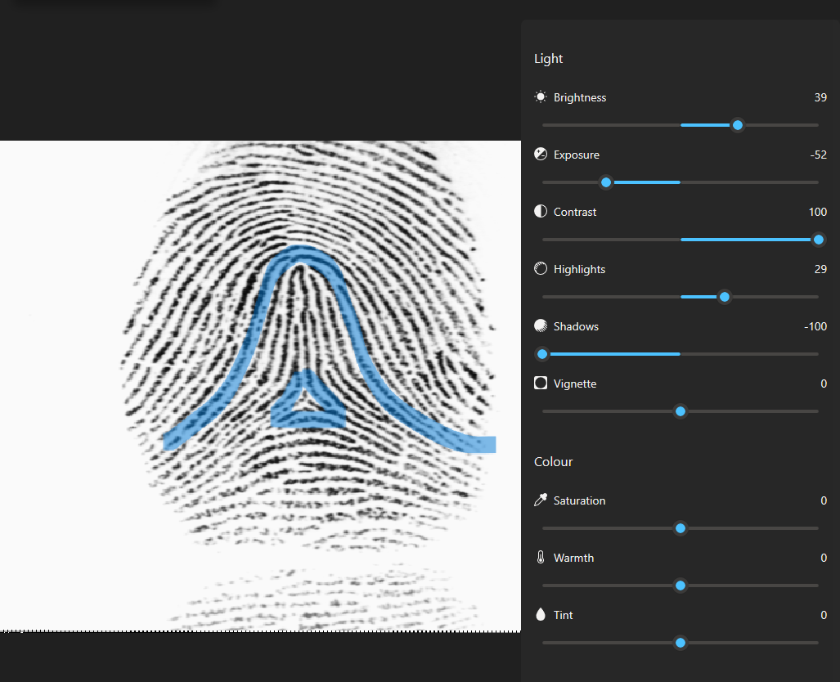

4. [10 points] Briefly describe the following terms: (a) Latent Fingerprints; (b) Volar Pads; (c) Orientation Field; (d) Level 3 Features; (e) Delta

1. Latent fingerprints: Fingerprints left on a surface after being touched by someone.
2. Volar Pads: Tissue grown on the fingertips and palms during embryonic growth that merges with the rest of the hands. Higher and symmetric volar pads tend to generate whorls, flatter and symmetric volar pads generate arches, and asymmetric volar pads tend to generate loops.
3. Orientation Field: The orientation field of a fingerprint image represents the directional pattern of the ridges. This can be used to categorize a fingerprint into one of the 6 major types.
4. Level 3 Features: These are represented using both inner holes(sweat pores) and outer contours(edges) of the ridges. The image resolution is >1000dpi and is no longer viewed as being simple, one-pixel wide skeletal images.
5. Delta: The point at where three ridge systems seem to meet.

5. [10 points] According to the article *Fingerprint Matching* by Jain et al., describe some of the challenges that exist in fingerprint recognition. **You must explain each challenge in detail.**

* Finger Shape/Image Quality
  + Fingers are obscurely shaped and sometimes require multiple scans to be properly documented. Similarly, fingers can be worn or have scars and cuts that disrupt the fingerprint pattern. New scanning technology is being designed to scan beneath the skin's surface to remove such interference.
* Small overlapping area and nonlinear distortion
  + Commercial sensors in mobile devices have small surface areas for acquiring fingerprints. This combined with the average user have untrained practices in fingerprint lead to subpar fingerprint recording. One possible solution is to increase the resolution of the scanner to acquire level 3 features. However, commercial scanners are normally low quality. Another solution is to create a fingerprint mosaic, but this requires a patient and cooperative user to supply multiple fingerprints of each finger.
* Latent Fingerprint Quality
  + Latent fingerprints are usually low quality images, distorted, low overlap, and have complex backgrounds. These images require significant human intervention to obtain viable identification. Techniques that would enhance imagery need to be developed to remove the human element.
* Altered/Fake Fingerprints
  + There are people who would use fake fingerprints in order to fool a biometric scanner. Also an individual could mutilate their own fingerprints to avoid being detected by a scanner. A cheap solution is to attach a liveness detector to a scanner that detects moisture or pulse. Another solution is to have software to restore mutilated fingerprints. A more simplistic solution would be to integrate multiple biometrics to compare a subject's fingerprints and facial features. This requires a larger database though.
* Interoperability
  + Different sensors can output different images that vary in resolution, size, contrast, background, and other distortions. There are also various algorithms that focus on different features within an image. There is no uniform template that standardizes the output for a matcher.
* Security
  + Systems using wireless data transmission have an added level of security risks. Data has to be encrypted and decrypted properly to produce results. Information also has to be kept secure and only accessible by authorized users and applications.
  + There is a noticeable amount of data loss when the information is encrypted which results in a lower system accuracy.

6. [10 points] Collect a few fingerprint images using your smartphone *camera* for this problem.

(a) Use any image editing program (e.g., PhotoShop, Gimp, Matlab, etc.) to manually crop out and obtain one image each of the following 8 fingers: left and right index fingers, left and right middle fingers, left and right ring fingers, and left and right pinky fingers.

(b) Use any image editing program to improve the “quality" of each image so that the ridges and valleys are clearly discernible (e.g., you can perform histogram equalization, change image contrast and brightness, apply gamma correction, etc.). Note: You do not have to write a program to enhance quality - the adjustment

can be done using existing image editing tools. But you are also allowed to write a program to improve the quality.

(c) What type of image processing operations did you conduct to improve the quality of each image?

* Increase brightness to remove background distortion.
* Alter exposure to clarify imagery.
* Maximize the contrast to embolden lines.
* Reduce highlights to embolden lines.
* Minimize shadows reveal smaller details within the fingerprint lines.
* Highlight or circle significant features.

(d) Manually mark at least 5 minutiae points in each of the 8 processed images. Also, mark the core and delta points, if present. Include these images along with the marked points in your report.

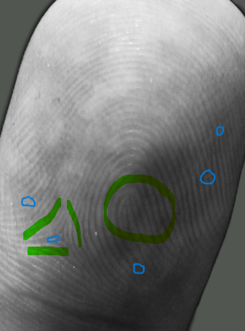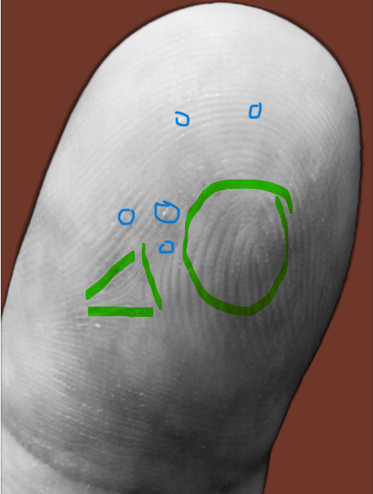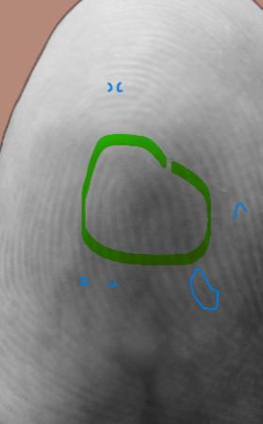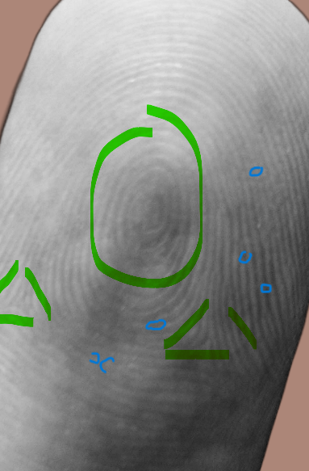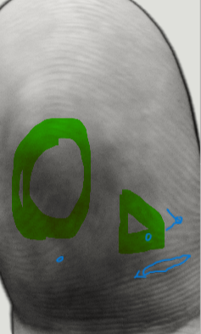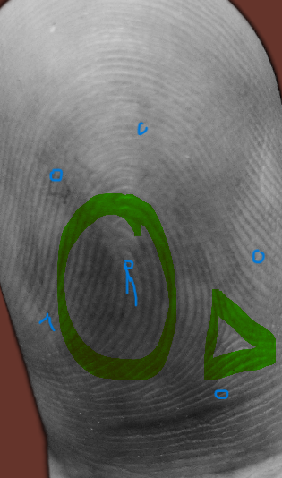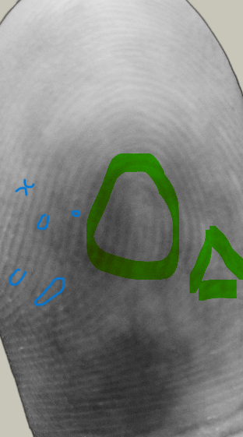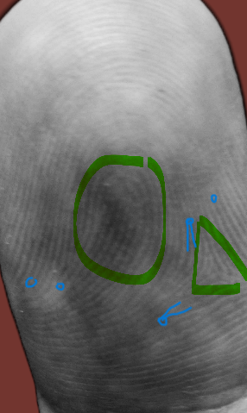

References:

1. <https://www.sciencedirect.com/topics/computer-science/orientation-field>
2. <http://www.cse.msu.edu/~rossarun/courses/fa22/cse402/reading/JainFpMatching_IEEEComp10.pdf>
3. <https://www.adobe.com/express/feature/image/remove-background>
4. https://www.bayometric.com/minutiae-based-extraction-fingerprint-recognition/